1. Purpose and Overview
This document specifies the functional requirements for a production-grade, multi-agent AI chatbot to be embedded on the company website. The system engages visitors, answers questions about the company's services using published case studies and content, qualifies visitors as sales leads, books discovery calls on a real calendar, and automatically sends a structured lead summary to the sales team's inbox end to end, without manual intervention.
The system is explicitly not a single chatbot driven by one large prompt. It is a coordinated set of five specialized agents - Orchestrator, Search, Scheduler, Lead-Summary, and Guardrail - each responsible for one job, communicating through a shared session state. This document defines what each agent and supporting subsystem must do, how they must behave under failure, and what a submission must demonstrate to be considered production-ready rather than a prototype.
2. Scope
In scope :
• A five-agent system (Orchestrator, Search, Scheduler, Lead-Summary, Guardrail) coordinating through a shared Supabase-backed session state.
• Retrieval-augmented answers grounded in the company's own published website content (pgvector).
• Real calendar booking via the Google Calendar API, with Google Meet links and visitor invites.
• Automated, structured lead summary emails to the sales team, including for abandoned sessions.
• Guardrail checks on every outgoing response and every incoming visitor message.
• Structured error handling, retry logic, and observability/logging across all agents.

System Overview :
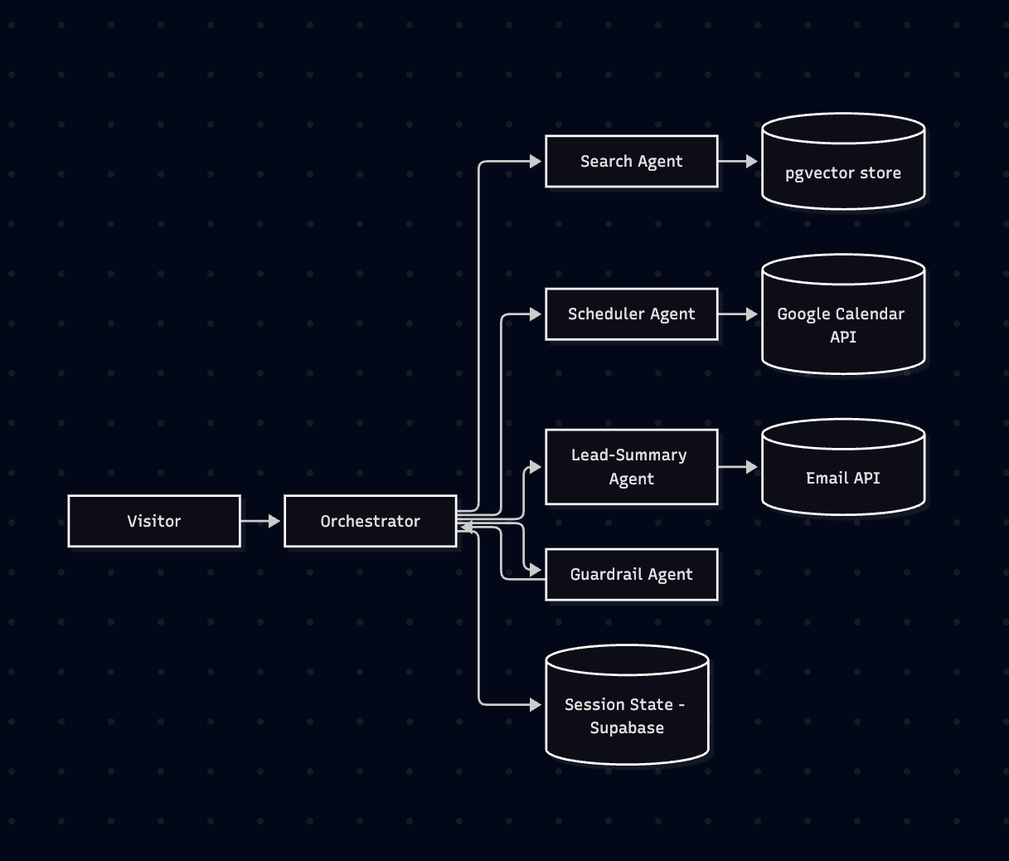
3. Content Research & Vector Store Setup
ID | Requirement
FR-1.1 | System shall source the company related information from the document attached, no assumed or invented content.
FR-1.2 | System shall produce short, self-contained source documents from that published content.
FR-1.3 | System shall chunk documents into sensibly sized pieces, with the chunk size and overlap chosen and justified (not arbitrary defaults).
FR-1.4 | System shall generate embeddings for each chunk and store them in Supabase using the pgvector extension.
FR-1.5 | System shall store metadata alongside each chunk: source page/section and document type, so a retrieved answer can cite where it came from.
FR-1.6 | System shall tag each chunk with a content category (e.g., service description, pricing, case study, FAQ) so the Search agent can optionally filter retrieval by category.

4. State & Session Storage (Supabase)
ID | Requirement
FR-2.1 | System shall define a schema storing conversation history, sales-qualification signals, and which agents have run, keyed by session ID.
FR-2.2 | System shall read and write session state on every turn, so the Orchestrator always has the latest context.
FR-2.3 | System shall correctly reload state when a visitor returns after a gap (e.g., 10+ minutes) — it must not start the conversation fresh.
FR-2.4 | System shall define and enforce a session expiry/cleanup policy so stale sessions do not accumulate indefinitely.
FR-2.5 | System shall identify a returning visitor via a persistent identifier (e.g., cookie or local-storage session ID) tied across a page reload or new tab, distinguishing them from a genuinely new visitor.
FR-2.6 | System shall handle concurrent writes safely - if a visitor sends a new message while a prior tool call (calendar/email) is still in progress, the schema and write pattern shall prevent state from being overwritten or lost.

5. Orchestrator Agent
ID | Requirement
FR-3.1 | System shall define a routing contract specifying the input/output shape each downstream agent expects, and how session state flows in and out.
FR-3.2 | System shall route each visitor message to the correct agent (Search, Scheduler, or Lead-Summary) based on classified intent.
FR-3.3 | System shall expose the Scheduler and Lead-Summary agents' actions as callable tools via MCP, invoked through proper tool/function calling — the Orchestrator (not hardcoded logic) decides when a tool call is needed.
FR-3.4 | System shall decide when a conversation has ended and trigger the Lead-Summary agent accordingly.
FR-3.5 | System shall handle multi-intent messages (e.g., a question plus a booking request) by sequencing, parallelizing, or asking a clarifying question — with the choice justified per case.
FR-3.6 | System shall ask a clarifying question rather than guessing when intent-classification confidence is low, instead of routing to the wrong agent.
FR-3.7 | System shall enforce a turn/session timeout, defining what happens if a visitor goes quiet mid-flow (e.g., after Search but before Scheduling), and how that ties into triggering the Lead-Summary agent for a partial/abandoned conversation.
FR-3.8 | System shall pass every outgoing response through the Guardrail agent before it reaches the visitor; this checkpoint is owned by the Orchestrator, not duplicated in each agent.
FR-3.9 | System shall log the routing decision for every message — which agent was chosen, why, and any tool calls made — for end-to-end traceability.
6. Search Agent
ID | Requirement
FR-4.1 | System shall rewrite the visitor's raw message into a better-formed search query before retrieval.
FR-4.2 | System shall retrieve relevant chunks from the pgvector store and generate a grounded answer with source citation.
FR-4.3 | System shall use a sensible top-k retrieval strategy and handle ambiguous queries or queries spanning multiple documents.
FR-4.4 | System shall decline or hedge, rather than guess, when no relevant chunk exists for the query.
FR-4.5 | System shall use conversation history from session state to resolve follow-up questions that depend on prior context.
FR-4.6 | System shall return multiple relevant chunks when a question spans more than one source document.
FR-4.7 | System shall include a confidence signal in the agent's output so the Orchestrator or Guardrail agent can decide whether to trust the answer or escalate.
7. Scheduler Agent
ID | Requirement
FR-5.1 | System shall integrate the Google Calendar API as a real, MCP-exposed tool - not a mock stub or an inline direct API call.
FR-5.2 | System shall check actual calendar availability and create a real calendar event when the visitor confirms a time, via a proper tool call.
FR-5.3 | System shall propose 2–3 concrete available slots (reading the calendar, filtering out busy times, staying within business hours) rather than asking the visitor to pick blindly.
FR-5.4 | System shall capture the visitor's time zone, display proposed slots in it, and store/book the event in the calendar owner's time zone.
FR-5.5 | System shall re-check availability immediately before creating the event (not only at conversation start) to prevent double-booking if the slot was taken in the interim.
FR-5.6 | System shall automatically include a Google Meet video-meeting link on the created event.
FR-5.7 | System shall send a calendar invite to the visitor's email as part of booking, so the event appears on their own calendar.
FR-5.8 | System shall support reschedule/cancel: if a returning visitor wants to change a booked time, the agent shall look up the existing event via session state and modify or cancel it, rather than creating a duplicate.
8. Lead-Summary Agent
ID | Requirement
FR-6.1 | System shall generate a structured sales lead summary from the entire conversation transcript and session state.
FR-6.2 | System shall send the summary via a real email API, exposed as an MCP tool and invoked via tool calling.
FR-6.3 | Email shall include: visitor info gathered, key questions asked, lead-qualification signals, meeting booked (if any), and a link back to the full conversation log.
FR-6.4 | System shall trigger the agent on the happy path (visitor confirms a booking or explicitly finishes) AND on an abandoned/timed-out session — a partial lead shall still be sent, flagged as incomplete.
FR-6.5 | Summary shall include a lead score or qualification tier (e.g., a numeric score) derived from the gathered inputs, so sales can prioritize their inbox.
FR-6.6 | System shall avoid duplicate sends for the same session - a second trigger updates the prior summary rather than sending a conflicting second email.
FR-6.7 | System shall record the email send back into session state as a completed, immutable event, so the Orchestrator knows a summary was already sent for that session.
9. Guardrail Agent
ID | Requirement
FR-7.1 | System shall run the Guardrail agent as an independent, callable component in the pipeline - not as inline conditionals duplicated inside other agents.
FR-7.2 | System shall check outgoing responses for hallucinated claims not grounded in retrieved docs, and for unauthorized commitments (specific pricing, contractual timelines, guarantees).
FR-7.3 | System shall check incoming visitor messages for prompt-injection attempts before other agents act on them.
FR-7.4 | System shall block a response that fails a check and substitute a safe fallback, rather than sending the invalid response.
FR-7.5 | System shall check for PII exposure in both directions — flagging if the conversation requests more personal data than needed, and blocking if the visitor requests sensitive data.
FR-7.6 | System shall check tone and brand safety — a response shall not be argumentative, overly casual, or leak internal reasoning (e.g., a visitor's qualification score or the reason they were routed a certain way).
FR-7.7 | System shall log every agent handoff and tool call (what was invoked, what it returned, what was decided) for end-to-end debuggability.
10. Reliability & Error Handling
ID | Requirement
FR-8.1 | System shall define fallback behavior when retries are exhausted - e.g., calendar failure offers manual-follow-up contact collection instead of failing silently; email failure queues for retry rather than losing the lead.
FR-8.2 | System shall distinguish retryable failures (timeout, rate limit, transient 5xx) from non-retryable ones (invalid credentials, malformed request, 4xx client errors), and shall not retry non-retryable failures.
FR-8.3 | Every sub-agent shall return a structured error JSON to the Orchestrator on failure -> {status, error_code, message, retryable, agent} — not a raw exception or plain string, so the Orchestrator can route programmatically and log uniformly.
FR-8.4 | System shall surface a clear, honest message to the visitor when something fails after all retries (what happened and what happens next), instead of a generic error or a silent hang.
FR-8.5 | System shall log every retry attempt and its final outcome (succeeded after N retries, failed and fell back, failed and gave up), feeding the same observability trail as the Guardrail agent's logging.
11. Acceptance Criteria
A submission is considered complete when it demonstrates, end to end:
• A visitor question grounded in real, website content (document attached), with a correct decline when no relevant chunk exists.
• Session state that survives a 10+ minute gap and reloads correctly on return.
• A multi-intent message (question + booking request) handled with a justified sequencing/parallel/clarify decision.
• A low-confidence message answered with a clarifying question instead of a wrong routing.
• A real calendar slot proposed, re-checked, and booked with a Google Meet link and a visitor-side invite - with no double-booking under a race condition.
• A sales lead-summary email sent on both a completed booking and an abandoned session, each correctly scored and never duplicated.
• At least one deliberately injected prompt-injection or PII-probing message correctly blocked by the Guardrail agent with a safe fallback.
• A simulated tool failure (e.g., calendar API down) correctly classified as retryable/non-retryable, retried or escalated per policy, and surfaced honestly to the visitor.
• End-to-end logs showing every routing decision, Agent call, Tool call, and Guardrail check for one full conversation..

All the best !!

